Thank you for joining us as we
Worship our Lord
December 12, 2021
10:15am Service

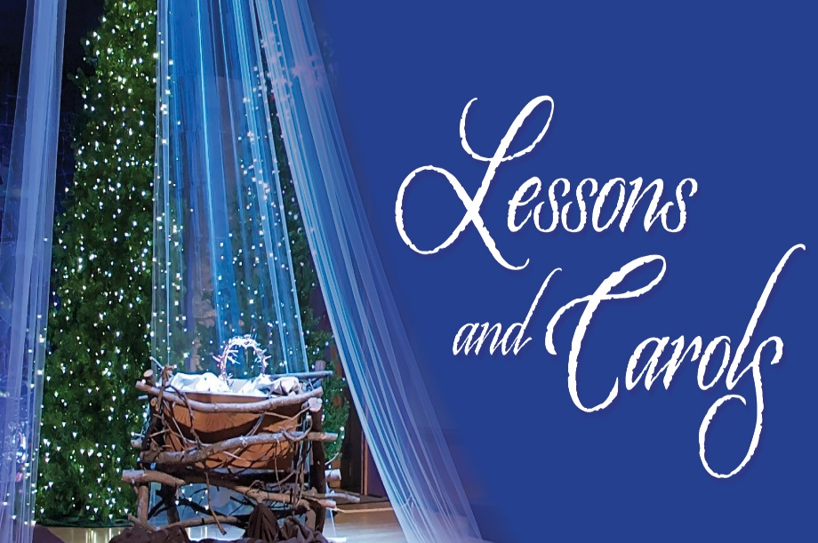

Rejoice greatly, O daughter of Zion! Shout aloud, O daughter of Jerusalem! Zechariah 9:9

Mount Olive Lutheran Church
6965 Chestnut Ridge Road, Lockport, New York
Contact us: (716) 434-8500 or office@mtolivelockport.org
Website: mtolivelockport.org
Facebook: Mount Olive Lutheran Church
Online Giving: https://app.easytithe.com/app/giving/mountolivelockport

STEWARDSHIP. . .

God's gifts to us are to be used in love for all who need them: our families, our church, and our community.

ALTAR FLOWERS
IN HONOR OF

Rick and Nancy Haseley
Happy 56th Anniversary!

Sunday, December 12, 2021
Blended Noncommunion Service

Pre-Service Music

LESSONS & CAROLS

WELCOME
Pastor: Let us pray:
Blessed are you, God of our salvation, you promised to send your messenger to prepare the way by building a highway straight and level and by preaching a baptism of repentance. As we light these candles, kindle among us the refiner’s fire, purify us of sin, and bring the good work begun in us to completion. Enlighten us with your grace, that we may serve our neighbors in need. Grant this through Christ our Lord, whose coming is certain and whose day draws near.
People: Amen

LIGHTING THE ADVENT CANDLE
Pastor: Jesus Christ is the Light of the world,
People: the light no darkness can overcome.
Pastor: Let Your light scatter the darkness
People: and illumine Your Church.
(Advent Candle is Lit)

“Light One Candle”

Chorus:
Light one candle for JOY
One bright candle for JOY
He brings JOY
to every heart
He comes! He comes!

Light one candle for joy
One bright candle for joy
Every nation will find salvation
in Bethlehem’s baby boy.
Chorus

He brings JOY to every heart
He comes, He comes

SHARING OF THE PEACE

INVOCATION
Pastor: In the name of the Father and of the † Son and of the Holy Spirit.
People: Amen.

CONFESSION
Pastor: “But test everything; hold fast what is good. Abstain from every form of evil.” Since we are gathered to hear God’s Word, call upon Him in prayer and praise, and receive the body and blood of our Lord Jesus Christ in the fellowship of this altar, let us first consider our unworthiness and confess before God and one another that we have sinned in thought, word, and deed, and that we cannot free ourselves from our sinful condition. Together as His people, let us take refuge in the infinite mercy of God, our heavenly Father, seeking His grace for the sake of Christ, and saying: God, be merciful to me, a sinner.
People: Almighty God, have mercy upon us, forgive us our sins, and lead us to everlasting life. Amen.
Pastor: “Now may the God of peace Himself sanctify you completely, and may your whole spirit and soul and body be kept blameless at the coming of our Lord Jesus Christ.”

ABSOLUTION

THE WORD

READING Isaiah 9:2-7

Carol: “God Rest Ye Merry Gentlemen”

God rest ye merry, gentlemen
Let nothing you dismay
Remember, Christ, our Saviour
Was born on Christmas day
To save us all from Satan's power
When we were gone astray
Chorus
O tidings of comfort and joy,
Comfort and joy
O tidings of comfort and joy

In Bethlehem, in Israel,
This blessed Babe was born,
And laid within a manger
Upon this blessed morn
The which His Mother Mary
Did nothing take in scorn
Chorus

From God our heav’nly Father
A blessed angel came
And unto certain shepherds
Brought tidings of the same
How that in Bethlehem was born
Son of God by name.
Chorus

READING Micah 5:2-5

Carol: “O Little Town of Bethlehem”

O little town of Bethlehem, how still we see thee lie
Above thy deep and dreamless sleep
the silent stars go by
Yet in thy dark streets shineth the everlasting Light
The hopes and fears of all the years
are met in thee tonight.

O Holy Child of Bethlehem, descend to us we pray
Cast out our sin and enter in, be born in us today
We hear the Christmas angels,
the great glad tidings tell
Oh come to us, abide in us, our Lord Emmanuel.

READING Luke 1:26-35, 38

Carol: “What Child is This”

What child is this who laid to rest
on Mary’s lap is sleeping?
Whom angels greet with anthems sweet
while shepherds watch is keeping
This, this is Christ the King,
whom shepherds guard and angels sing
Haste, haste to bring Him laud,
the Babe the son of Mary

Why lies he in such mean estate
where ox and ass are feeding?
Good Christian fear for sinners here
the silent Word is pleading
Nails, spear shall pierce Him through,
the cross be borne for me for you
Hail, hail the Word made flesh,
the Babe, the son of Mary

So bring Him incense, gold and myrrh,
come peasant, King to own Him
The King of Kings salvation brings
let loving hearts enthrone Him
Raise, raise the song on high
the virgin sings her lullaby
Joy, joy for Christ is born the Babe,
the son of Mary.

READING Luke 2:1-7

Carol: “Away in a Manger”

Away in a manger, no crib for his bed
The little Lord Jesus laid down his sweet head
The stars in the bright sky looked down where he lay
The little Lord Jesus asleep on the hay
The cattle are lowing, the baby awakes,
But little Lord Jesus no crying he makes.
I love Thee, Lord Jesus, look down from the sky
And stay by my cradle till morning is nigh.
Be near me, Lord Jesus, I ask Thee to stay
Close by me forever, and love me, I pray.
Bless all the dear children in thy tender care,
And take us to heaven, to live with Thee there.

READING Luke 2:8-14

Carol: “Angels We Have Heard on High”

Angels we have heard on high,
sweetly singing o’er the plains;
And the mountains in reply echoing
their joyous strains.

CHORUS:
Glo………ria in excelsis Deo!
Glo………ria in excelsis Deo!

Come to Bethlehem and see Him
whose birth the angels sing;
Come, adore on bended knee Christ,
the Lord, the new-born King.
CHORUS

READING Luke 2:15-20

Carol: “Little Drummer Boy”

Come they told me (pa-rum pum pum pum)
A newborn King to see (pa-rum pum pum pum)
Our finest gifts we bring (pa-rum pum pum pum)
To lay before the King (pa-rum pum pum pum)
So to honor Him (pa-rum pum pum pum)
when we come

Little Baby (pa-rum pum pum pum)
I am a poor boy too (pa-rum pum pum pum)
I have no gift to bring (pa-rum pum pum pum)
that's fit to give our King (pa-rum pum pum pum)
Shall I play for You? (pa-rum pum pum pum)
On my drum

Mary nodded (pa-rum pum pum pum)
The ox and lamb kept time (pa-rum pum pum pum)
I played my drum for Him (pa-rum pum pum pum)
I played my best for Him (pa-rum pum pum pum)
Then He smiled at me (pa-rum pum pum pum)
Me and my drum

READING Luke 2:21-35

Carol: “Mary Did You Know”

Mary, did you know that your baby boy
would someday walk on water?
Mary, did you know that your baby boy
would save our sons and daughters?
Did you know that your baby boy
has come to make you new?
This child that you‘ve delivered
will soon deliver you.

Mary, did you know that your baby boy
will give sight to a blind man?
Mary, did you know that your baby boy
will calm a storm in His hand?
Did you know that your baby boy
has walked where angels trod?
When you’ve kissed your little baby,
Then you’ve kissed the face of God.

Mary did you know? Mary, did you know?
The blind will see, the deaf will hear,
The dead will live again.
The lame will leap, the dumb will speak
the praises of the Lamb.

Mary, did you know that your baby boy
is Lord of all creation?
Mary, did you know that your baby boy
will one day rule the nations?
Did you know that your baby boy
was Heaven’s perfect Lamb?
This sleeping Child you’re holding is the great
“I AM”

READING Matthew 2:1-11

Carol: “We Three Kings”

We three kings of orient are
bearing gifts we traverse afar
Fields and fountains, moor and mountains
following yonder star

Refrain: O star of wonder, star of night,
Star with royal beauty bright,
Westward leading, still proceeding,
Guide us to thy perfect light.

Born a King on Bethlehem's plain,
Gold I bring to crown Him again
King forever, ceasing never, Over us all to rein
Refrain

Glorious now behold Him arise,
King and God and sacrifice
“Alleluia, alleluia!” earth to the heav’ns replies.
Refrain

READING Matthew 2:13-23

Carol: “Jesus, Name Above All Names”

Jesus, name above all names,
Beautiful Savior, Glorious Lord,
Emmanuel, God is with us,
Blessed Redeemer, Living Word.

Jesus loving Shepherd, Vine of the branches
Son of God, Prince of Peace, Wonderful Counselor,
Lord of the Universe, Light of the World.

Jesus, born in a manger,
Son of Mary, humble at birth
Angels sang, shepherds adored Him
Let us go join them, worship the Child.

PRAYERS OF THE CHURCH
When there is no communion, Pastor will give prayers as guided by the Holy Spirit.
Pastor: Lord in Your Mercy
People: Hear Our Prayer

LORD’S PRAYER Matthew 6:9–13
Taught by our Lord and trusting in His promises, we are bold to pray:
Our Father who art in heaven,
hallowed be Thy name,
Thy kingdom come,
Thy will be done
on earth as it is in heaven;
give us this day our daily bread;
and forgive us our trespasses
as we forgive those who trespass against us;
and lead us not into temptation,
but deliver us from evil.
For Thine is the kingdom
and the power and the glory
forever and ever. Amen.

FIRST FRUITS OFFERING

BENEDICTION
Pastor: May you be filled with the wonder of Mary, the obedience of Joseph, the joy of the angel, the eagerness of the shepherds, The determination of the magi, and the peace of the Christ Child. Almighty God, Father † Son, and Holy Spirit, Bless you now and forever.
People: Amen.

SENDING SONG
“Joy To The World”

Joy to the world! The Lord is come.
Let earth receive her King
Let every heart
Prepare Him room
And heaven and nature sing
And heaven and nature sing
And heaven and heaven and nature sing

Joy to the world, the Savior reigns
Let men their songs employ
While fields and floods
Rocks, hills and plains
Repeat the sounding joy
Repeat the sounding joy
Repeat, repeat, the sounding joy

He rules the world with truth and grace,
And makes the nations prove
The glories of His righteousness,
And wonders of His love;
And wonders of His love;
And wonders, wonders of His love.

A very warm thank you to the
following people:

Megan Menges
for the lovely Readings.

The Praise Team

and to our Pastor.

To all of you for making this a beautiful service!

† † †

